
Period Poverty Statement

Period Products (Free Provision) Act (Northern Ireland) 2022 (“the Act”)

The Introduction of the Period Products (Free Provision) Act (Northern Ireland) 2022 (“the Act”) stipulates that from 12 May 2024, the College has a statutory duty to provide period products free of charge on its premises. Fortunately the College has had a provision in place since February 2019 which has expanded since then.

Aim of the Act
  - The overarching aim of the Act is to ensure period products are provided free of charge to all persons in Northern Ireland who need them. Furthermore, the Act specifies that arrangements established to meet this aim must ensure the following:
- that the period products are obtainable, by users, reasonably easily and in a way that respects the dignity, privacy and confidentiality of the persons obtaining them;
- that a reasonable choice of different types of period products are made available, having regard to articles which are reusable; and
- that the availability of free products and the arrangements for obtaining them are publicised in a way that respects dignity, privacy and confidentiality.

Requirement to Publish a Written Statement
The Act also specifies that the College must prepare and publish a written statement on the arrangements which have been established to provide free period products on its premises.

The written statement must include the following:

- details of the consultation conducted;
- the agreed arrangements (for the provision of free period products) which have been established; and
- how the College has, in developing these arrangements, had regard to DfE’s guidance and feedback received through the consultation phase.

Consultation
The College consulted with staff and students to determine the arrangements to be put in place. The questions centred on
- Which products should be made available
- Where they should be placed
- How they should be accessed, and
- How they should be publicised.

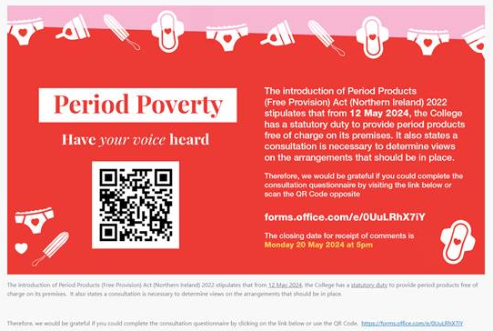

A total of 88 responses were received and feedback presented was considered and resulted in agreed arrangements being made.

Agreed Arrangements
Following consultation the following arrangements have been agreed to be in place

- Provision of a range of tampons and pads, as well as liners
- These will be placed in all female, all gender and disabled toilets across all buildings
- They will be easily and openly accessed as outlined above, however they will also be discretely held by designated staff in each campus
- Their availability will be communicated via staff and student portals, social media and at staff and student inductions.

Commitment
North West Regional College is committed to promoting the availability of products and will seek routinely feedback from relevant stakeholders to evaluate uptake and the range of options available.

