
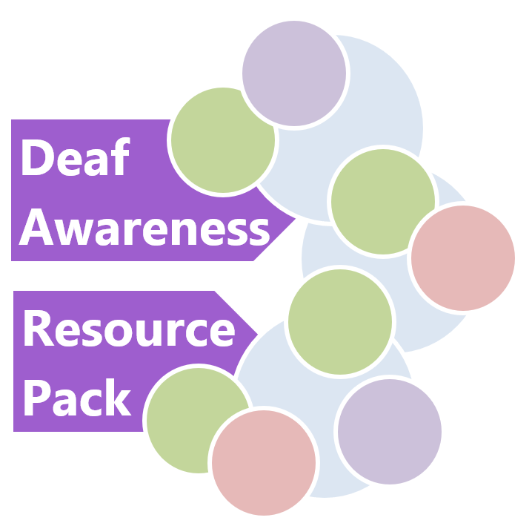
Content Page No

1 College Commitment, Introduction, Monitoring 4

2 Types of Deafness 5

3 Relay 10

4 Communication Professionals 13

5 Access to professional support 17

  - Process 17

Organisations providing support 18
6 Additional Technology 20
7 Portable Loop Systems 23

- Portable Loop system Procedures 23
- Loop systems available in the College campuses 24

8 Communication Tips 27

- Communication Tips if you have a hearing loss 27
- Communication Tips when speaking to someone 28
with a hearing loss
- Communicating with Deaf Students 29
9 Classroom Strategies for Lecturers of Hearing Impaired 31
Students

10 Reasonable Adjustments - Considerations 33
11 Use of Hearing Dogs 37

12 Access to Work (NI) 38

13 College Accessible Information Policy 41

14 Additional Support Organisations for Deaf and 42
Hard of Hearing People

15 Face Coverings and Deafness 46

16 Communicating with Deaf Children 47

1 College Commitment

The College is committed to providing the best possible service to deaf/hard of hearing students, potential students, customers and staff.

Introduction

This Resource Pack has been sourced from College staff, the National Deaf Children’s Society and Royal National Institute for Deaf People.

The Pack has been developed to provide some guidance and information on services available for people with hearing loss. The content will be updated regularly to ensure it remains relevant. If you have hearing loss or if you are aware of a colleague or student that may be in need of support please refer to this pack for information on support available.

Monitoring

This Resource Pack will be monitored quarterly and formerly reviewed annually around 1st June each year through the College’s Equality Working Group.

2 Types of deafness

Deafness is not a learning disability and deaf students have the potential to achieve as much as any other student, given the right support and access to the curriculum. However, deaf students may experience particular challenges, as most teaching and learning takes place through seeing and hearing.

Levels and types of deafness

There is considerable variation in the levels and types of deafness. Deaf young people may have a permanent mild, moderate, severe or profound hearing loss in one or both ears, or a temporary loss such as glue ear.

There are two main types of deafness:

- Sensori-neural deafness: due to an issue with nerves in the inner ear where the cochlear is not functionally normally.
- Conductive deafness: due to an issue with the outer or middle ear preventing sound from travelling through to the inner ear. It is usually temporary but can be permanent. Glue ear is a common form of conductive deafness.

Levels of deafness:

Deafness is measured in two ways:

- How loud the sound has to be so that the young person can hear it, measured in decibels (dB).
- Which frequencies (pitches) the young person can or cannot hear, measured in hertz (Hz).

Each young person’s deafness is different depending on which frequencies are affected and how loud a sound has to be before they can hear it.

Few young people are totally deaf. Most can hear some sounds at certain pitches and volumes, known as ‘residual hearing’. There are different degrees of deafness which are classified below.

Mild deafness

Many deaf young people with mild deafness may not use hearing aids. The impact of mild deafness can, however, be significant.

- Students can usually hear everything that is said to them in a quiet room but not if there is background noise or if they are far away from the speaker.
- A student is not likely to be able to follow a whispered conversation.

Moderate deafness

- Most students with moderate deafness will wear hearing aids.
- Without hearing aids, they may struggle to follow what someone is saying, particularly if the person is not speaking clearly.
- With hearing aids, they are likely to be able to follow a conversation in a quiet room.
- They will find it extremely difficult to follow a conversation in a large group if there is background noise or if they are far away from the speaker.

Severe deafness

- A student will be unable to access conversation at normal levels without hearing aids, but may be able to hear loud sounds such as a dog barking or a drum.
- With hearing aids, most students will be able to understand someone speaking in a quiet room provided the speaker is within two to three metres of them.
- A student may require communication support or additional technology (eg a radio aid) to understand speech in the presence of background noise, or to follow a group conversation.

Profound deafness

- Many profoundly deaf students will use hearing aids or a cochlear implant.
- Without a cochlear implant or hearing aids, a student will not be able to hear speech or other sounds. They may be able to feel very loud sounds such as a lorry passing them in the street.
- Even with hearing aids or cochlear implants, a student may require communication support such as a sign language interpreter or a speech to text reporter to access speech, especially where there is background noise or within a group conversation.

Visual representation of the loudness and pitch of a range of everyday sounds
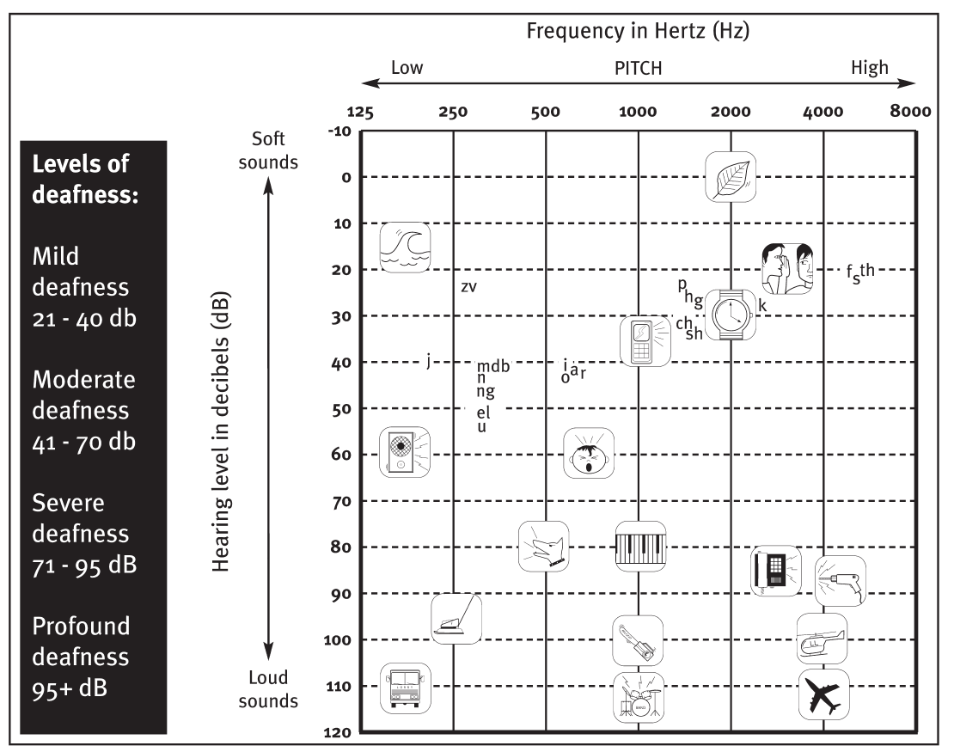
Unilateral deafness

This is when someone has little or no hearing in one ear but ordinary levels of hearing in the other. The student will find it difficult to localise sound. They may find it harder to understand speech when there is background noise or follow group conversations.

Auditory neuropathy spectrum disorder

Auditory neuropathy spectrum disorder occurs when there are faults which affect how sound is transmitted along parts of the auditory nervous system. It affects the brain’s ability to process all sound, including speech. Students will experience fluctuating hearing levels and often find it difficult to access speech, especially in the presence of background noise. Some students with auditory neuropathy spectrum disorder will use hearing aids; others will not find them beneficial and therefore not use them.

3 How Relay UK works for business
(Relay UK)

Relay UK is a relay service that enables people with little or no hearing, or people with speech difficulties, to communicate with hearing people over the phone.

It's like a 3-way call between a deaf or speech-impaired person, a hearing Relay Assistant, and you.

Overview

The deaf or speech-impaired person can either download the Relay UK app on their mobile, tablet, or computer or use a textphone.

They call your number using a prefix that connects them to Relay UK and a Relay Assistant – sitting in one of BT's relay centres – who speaks and listens to you and then types what you say for the deaf person to read on their screen.

They then type back or they can speak (as not all deaf people are speech-impaired too) for the Relay Assistant to read and speak to you.

It’s an idea that’s been around for years. Originally set up by the Royal National Institute for the Deaf (RNID), the modern twist is that the conversations can now be faster and more fluent. This is because the deaf person doesn't have to wait for you to finish speaking before they type to you.

Now when using the Relay UK app the experience is much closer to an actual speech conversation.

Can I still use my textphone?

Not everyone wants to use a mobile, tablet, or computer to make their calls. If you want to carry on using your textphone (Minicom/ Uniphone), that's fine.

You can still make calls in the usual way. All you need to do is dial 18001 followed by the phone number of the person you want to call

It really is that easy.

1 Dial 18001 followed by the phone number (including the dialling code).

You’ll see 'Relay UK ring ring' on your textphone screen. If your call is answered, you’ll see:

1. 'Relay UK Answered, please wait for connection'
2. 'Relay UK Waiting for a free relay assistant'
3. 'Connected to Relay, please wait'

The Relay Assistant won’t come on the call if it’s not answered.

2 Type your conversation

Once you're connected, you can type or speak your conversation. The Relay Assistant will type back anything the hearing person says.

3 Enjoy your chat

The conversation will carry on this way until one of you ends the call.

How to answer a Relay UK call on your textphone

It’s the same as answering other calls on your textphone except you’ll see some different messages.

The textphone rings or flashes. You'll see 'Relay UK. Waiting for a free relay assistant', or 'Relay UK. Connected text to text' if the call was made from a textphone or the Relay UK app.

If the call is from a hearing telephone user, you'll then see 'Connected to Relay, please wait'.

Once you're connected, carry on as normal.

For more information go to www.relayuk.bt.com

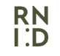
4 Communication Professionals

Using communication support

If you are deaf or hard of hearing or if you are working with colleagues or students who are deaf or hard of hearing, it may be necessary on occasions to access support from Communication Professionals.

There is a range of communication support services available (see below). Consider a service that suits you and your communication needs. However it should be noted that some services may be difficult to access in this area.

- Sign Language Interpreters

Sign language users in Northern Ireland are likely to either use British Sign Language (BSL) or Irish Sign Language (ISL). BSL/ISL interpreters help communication with people who are deaf and whose first or preferred language is BSL/ISL. They interpret from BSL/ISL to spoken or written English, or vice versa.

- Interpreters and Communicator Guides for people who are deafblind

Interpreters and Communicator Guides help people who are deafblind and people who are hearing to communicate with each other. They work with a range of communication methods, including:

• BSL/ISL;
• hands-on signing;
• the Block Alphabet;
• the Deafblind Manual Alphabet;

Interpreters work in formal settings, such as training courses. Communicator Guides work more informally – for example, they could help you to write a letter or do an everyday activity such as shopping.

- Lipspeakers

Lipspeakers work with people who prefer to communicate through lipreading and speech. You should be a confident lipreader with good English skills to use one. People who are deaf and people who are hearing can use lipspeakers to help them communicate with each other.

Lipspeakers:

- repeat what is said without using their voice, so that you can lipread them easily;
- produce the shape of words clearly, with the flow, rhythm and phrasing of speech;
- use natural gestures and facial expressions to help you follow what is being said;
- may also use fingerspelling if you ask them to.

- Speech-to-text reporters (STTRs)

Speech-to-text reporting is suitable for people who have a hearing loss or who are deaf and comfortable reading English, often at high speed and sometimes for up to a couple of hours at a time. STTRs type words phonetically – how they sound rather than how they are spelled. These are then converted back into English on a computer screen.

- Electronic Notetakers

Electronic Notetakers work with people who have a hearing loss, or who are deaf and comfortable reading English. They type a summary of what is being said on a laptop computer. You can then read this information on a screen in front of you. Electronic notetaking means you have fewer words to read compared with speech-to-text-reporting, and you won’t get a full word-for-word report. If you wish to read everything that is said, you may prefer to use a Speech-To-Text Reporter.

- Manual notetakers

Manual notetakers take handwritten notes in meetings, on courses and at other events for people who are deaf and comfortable reading English.

It’s quite common to use an electronic or manual notetaker in combination with another communication service. For example, if you are watching a BSL/ISL Interpreter or a Lipspeaker, it would be impossible for you to take notes and follow what is being said at the same time.

Electronic and Manual Notetakers may specialise in a particular field. If you are taking a science degree, for example, it’s important that your notetaker knows something about the subject. If you have very specific needs, you may need to spend time finding the right notetaker to support you.

5 Access to professional support

Process

If you require access to professional support you must ensure you follow the procedure below.

- When a need for communication support has been identified it is necessary to get approval to proceed from the budget holder in your Department.

- When approved by the Budget Holder you should access, by clicking here the National Registers of Communication Professionals working with Deaf and Deafblind people (NRCPD).

- Obtain the appropriate number of quotations (College procurement processes must be complied with).

- Confirm arrangements with the selected supplier who will forward a booking form for completion.

- Complete the booking form provided by supplier, and have it signed by the Budget Holder.

- Arrange to have a requisition put on Agresso as soon as possible.

Organisations providing support

Below are contact details of organisations from whom you can obtain quotations of cost. If the support is needed for a staff member you may wish to contact NRCPD or RNID whereas support for students will be provided by MPA.

The National Registers of Communication Professionals with Deaf and Deafblind People (NRCPD)

The National Registers of Communication Professionals with Deaf and Deafblind People (NRCPD) regulates communication professionals who work with deaf and deafblind people. Their job is to safeguard the wellbeing and interests of people who rely on those professionals and can be contacted if support is needed for staff.

Their contact details are:

Telephone 0191 323 3376
SMS 07526 173 329
Email enquiries@nrcpd.org.uk

Royal National Institute for Deaf People (RNID)

RNID provides support for people with hearing loss and tinnitus and they may be contacted if staff need support. RNID provides communication support based on identified communication needs. They can also offer advice on the most suitable type of communication support and book communication support on your behalf.

Their contact details are:

Telephone 08088080123
Text 07360 268 988
contact@rnid.org.uk https://rnid.org.uk/

6 Additional technology

For those using hearing technology of any kind, large rooms, poor acoustics, background noise and large groups make listening and accessing what is said difficult. The college can make it considerably easier for the deaf student (and others) by providing additional technology and by managing background noise and acoustic conditions.

Radio aids

Radio aids are essential for some deaf students. They reduce the problems caused by the distance between the student and lecturer and by background noise. Radio aids consist of two parts:

- a transmitter worn by the lecturer
- a receiver worn by the student (usually attached to their hearing aid, bone conduction hearing implant or cochlear implant).

The lecturer’s voice is then transmitted via radio waves directly to the receiver worn by the student.

Advice should be sought from a qualified Teacher of the Deaf or educational audiologist about which system best suits the student’s needs, its effective use and its maintenance.

When using radio aids, lecturers and tutors should be reminded to:

- ensure the transmitter is switched on
- wear the microphone about 15cm from the mouth
- check with the student that the aid is working
- avoid standing in a noisy place, such as next to an overhead projector or open window, as the microphone will pick up background noise and transmit this to the deaf student
- avoid letting the microphone knock against clothing, lanyards or jewellery, as this as this will produce feedback.

Streamers

These are similar to radio aids. However, they usually only work with hearing aids or cochlear implants from the same manufacturer that produced the streamer. For example, an Oticon streamer will only work with an Oticon hearing aid.

Soundfield system

A soundfield system reduces the impact of distance between the speaker and student. The tutor’s voice is transmitted via a microphone to a base station placed within the room. This amplifies and enhances the speech and then broadcasts it from speakers that are carefully positioned around the room. This enables the tutor’s voice to be accessible, at normal conversational levels, across a significant area.

Acoustics and background noise

No technology can replace normal hearing, and its effectiveness depends on the acoustic quality of the college. The listening environment can make it difficult for deaf students to make the best use of their hearing technologies. Adaptations can be made to improve the acoustic quality of teaching spaces by reducing reverberation/echo, such as adding carpets, blinds or curtains at the windows, low ceilings with acoustic tiles, plenty of soft surfaces, soft wall displays and reducing noise from heating systems where possible.

Loop systems

Loop systems reduce background noise. A microphone picks up sound from the speaker (or a radio/TV) and feeds it to a wire loop running round a room. The student in the room then switches their hearing aid or cochlear implant to a T-setting so that it picks up sound from the loop.

Loop systems are not widely used in educational settings, but may be available in some lecture rooms and theatres.

Portable Hearing Loops and Infrared Systems - What are they and how do they work?
Portable loops work in the same way as permanently fitted loop systems. However, they cover a smaller area and can be packed away after use. They are useful if you do not need a permanent system fitted or the loop is needed in different rooms. You should be aware that the signal quality provided by a portable loop may not be as good as that from a professionally fitted system. You can also get portable infrared systems which have similar features to permanently fitted systems, but like portable loops they can cover a smaller area and can be packed away after use.

7 Portable Loop Systems

Portable Loop System Procedures

Procedure on how to request a portable loop system

Both the portable hearing loop systems and the infrared portable hearing loops, are available via the IT Helpdesk. The normal Helpdesk request process (Ticket) will apply and should include details of who the device is for, what location and duration of loan (start and end date). A secure location will be required for the loaned equipment. IT Helpdesk staff will advise of any conditions that apply.

Procedure on how to report a fault with a loop system

Labels are attached to each portable loop system indicating that if there are any technical issues then the IT helpdesk should be contacted. The helpdesk number is Ext 6565. This provides a mechanism for reporting faults and/or receiving assistance with the unit. If after an IT technician has provided assistance and the unit fails to work and a visitor to the College wishes to make a complaint, the College’s Complaints Procedure will apply.

How to use a Portable Loop System

Guidance on how to use the Portable Loop System and the Classroom Portable Loop System can be found by clicking on this link to the College's Intranet.

Loop Systems available in the College Campuses

Property Name |  | Details
Tower Building | Induction Loops | - C104 - Student Services - Portable Loop unit;  - C150 - Careers Academy - Fixed Loop under Desk;  - C170 - Library – 2 x Portable Loop unit;  - C261 – HR Reception - Portable Loop unit;  - C221A - Training Unit reception – Fixed loop under desk;  - C221C - IT Services reception – Fixed loop under desk;  - C270 – Finance Reception - Fixed Loop installed.
Tower Courtyard (Annex) | Induction Loops | - E104 – Lounge – Linked to audio system TV  - E105 – Teaching Space - Linked to audio system / Screen  - E105A – Bedroom – Linked to audio system TV  - E106 – Hub Classroom - Linked to audio system / Screen  - E108A – Reception desk - Fixed Loop under Desk;
Strand Building | Induction Loops | - B101 – Main Reception - Fixed loop system under desk;  - B103 – Admissions desk – Portable Loop unit;  - B103 - Admissions desk - Phone calls – Text phone
Lawrence Building | Induction Loops | - A106 – Lecture Theatre – Fixed loop system  - A117 – Classroom amplifier with its mic attachment
Foyle Building | Induction Loops | - F104 - Theatre - Permanent with mic attached;  - F501 - HB Reception - Fixed loop under desk  - F601 - HB Reception - Fixed loop under desk
Springtown Centre | Induction Loops | - S112 - Conference - Fixed Loop device;
Limavady Main Building | Induction Loops | - Library LRC;  - Reception Desk Area;  - A4 - Training Kitchen;  - E08 - Lecture Theatre
West Wing Limavady | Induction Loops | - WO1 – Classroom – Fixed loop unit;
Benevenagh Building  Limavady | Induction Loops | - A5 – Classroom – Fixed loop unit;  - A7 - Beauty Salon – Fixed loop unit;  - A8 - Hair Salon – Fixed loop unit;  - D7 - Classroom – Fixed loop unit.
Greystone Campus  (Limavady) | Induction Loops | - Reception Desk Area – Fixed loop unit.
Strabane Campus | Induction Loops | - H102 - Reception Desk Area - Fixed loop unit;  - H161 - Library LRC Desk Area - Fixed loop unit;  - H189 - Beauty Cabin Reception - Fixed loop unit.
Estates Store (Tower)  Spares for issue | Induction  Loops | - Portable loop case 1;  - Portable loop case 2;  - 2 x Portable loop unit – Desk mounted;  - Fixed system unit – Spare Inc. Mic.
Northland Building | Induction Loops | - D306 – Lecture Theatre – Fixed loop unit  - D308 – Boardroom – Fixed loop unit

8 Communication Tips

Communication Tips if you have a hearing loss

The following are communication tips to help you if you have a hearing loss:

- Be open: tell the person you’re speaking to that you have a hearing loss;

- Ask people to get your attention before they start talking to you;

- Get a better view: stand a reasonable distance from the person so you can see their face and lips. Gestures and facial expressions will help you understand what they’re saying;

- If necessary, ask people to slow down and speak more clearly;

- If you don’t catch what someone says, just ask them to say it again or in a different way;

- Keep calm: if you get anxious, you might find it harder to follow what’s being said;

- Play to your strengths: if your hearing is better in one ear, try turning that side towards the person speaking to you;

- Learn to lipread: everyone does it a bit, especially in noisy places;

- Be kind to yourself! No one hears correctly all the time.

Communication Tips when speaking to someone with a hearing loss

The following are communication tips to help you when speaking to someone with a hearing loss:

- Always ask: even if someone’s wearing a hearing aid, ask if they need to lipread you;

- Make sure you have the person’s attention before you start speaking;

- Find a place to talk that has good lighting, away from noise and distractions;

- Turn your face towards them so they can easily see your lip movements;

- Speak clearly, not too slowly, and use normal lip movements, facial expressions and gestures;

- Make sure what you’re saying is being understood;

- If someone doesn’t understand what you’ve said, try saying it in a different way;

- Keep your voice down: it’s uncomfortable for a hearing aid user if you shout and it looks aggressive;

- Get to the point: use plain language and don’t waffle;

- If you’re talking to one person with hearing loss and one without, focus on both of them.

Communicating with deaf students

There are lots of ways you can help a deaf student to understand what you are saying.

- Allow the student to see your face to aid lip-reading. Try not to impede their view of your face with hair, hands or objects, or by turning to write on the whiteboard.

- Stay at the front of the room and minimise moving around. Ensure you are not standing with your back to a light source (eg an interactive whiteboard or a window), as a shadow cast across the face can impede recognition of lip patterns.

- Ask the deaf student where they would prefer to sit, as this will aid communication depending on their type of hearing loss and the hearing technologies they use. The student’s cochlear implant or hearing aid has an optimal range of one metre in which to access speech clearly. Being seated just back from the front, to the side, enables the student to view most clearly what is being said by students around the room.

- Speak clearly and at your normal pace. Be aware that speaking too slowly or over-exaggerating your mouth patterns will make it harder for the student to understand, distort the speech signal and make it more difficult to lip-read. Both shouting and whispering make mouth patterns and the speech signal more difficult to understand.

- Make sure that you have the student’s attention before you start talking.
- Check that the student has understood what was said. If not, repeat or rephrase what you have said. Repeat contributions and questions from other students – this will benefit hearing students too.

- Work with specialist communication support staff to deliver the lecture at an appropriate pace for signing and notetaking.

- Speak directly to the student, not to the communication support worker or interpreter.

- Ensure audio material is subtitled/captioned, offer a transcript or provide an overview during the lesson.

- Check that any hearing technology controlled by yourself is working, such as a soundfield system.

- If a lecture requires lights to be turned off (eg to watch a DVD), make sure all spoken instructions or explanations are given before the lighting is dimmed.

- Monitor how well the student is able to communicate with their peers and how well they respond.

9 Classroom Strategies for Lecturers of Hearing Impaired Students

The following includes some common situations you may face in your classroom and some suggested strategies for handling them.
There are a lot of students in the classroom...
- Try to devise or agree a set of hand signals and/or gestures to get the students' attention.
- Try to set up a system which pairs a hearing person with a deaf or hard of hearing person to assist with questions in the classroom.
- Deaf people will be aware of situational changes. If everyone in the class is facing forward and appears to be getting ready for work, the deaf person will do the same.
- Establish routines for beginning and ending of class.
  - For example: first, take attendance; second, check homework; third, share information, etc.
  - This allows everyone in the class to attend to the content and not worry about the circumstances of the environment.

The deaf person appears bored...

- Check on the student's understanding of what is going on in the class.
- Check to see if the goals and objectives for participation and learning are clear.
- Check the level of participation of the deaf students. They may be unsure of how to participate in the class and need some direction from the lecturer in order to become more involved.
- Arrange materials and assignments so that all students experience frequent small successes. That will make them eager to be involved in the class.
- Use visual enhancements as much as possible -- charts, graphs, overheads, video tapes, etc.
- Make sure that arrangement of chairs is conducive to class interaction.
- The deaf or hard of hearing person may simply not be interested.

The interpreter didn't show up...
- Don't panic.
- Arrange for another student to take notes for the deaf person.
- Show a captioned movie or video tape.
- Change seating arrangement (if possible) to allow the deaf or hard of hearing person to sit closer to you.

I am giving a written test, but I know that English is not the student's first language...

- Give the test orally.
- Rely on the integrity of the interpreter to sign the test without giving away any of the answers.
- Give the test as a take-home test to allow sufficient time.

I am using slides as part of my presentation so I must turn off the overhead lights...

- Think ahead and obtain a small light on a stand that will illuminate only the interpreter.
- Leave just the back lights on in the class.

I want to make sure that the deaf and/or hard of hearing person really understands what is going on in my class...

- Avoid asking questions that require a simple yes or no answer. Ask open ended questions like "What do you think," or "What is your opinion?" These types of questions allow the Lecturer to see if the question was accurately understood.
- If you think your question was not understood, rephrase it using different words.
- Use as much visual stimulation as possible.
- Provide outlines of what will be covered in class.
- Encourage class participation on the part of the deaf and/or hard of hearing person.

10 Reasonable Adjustments - Considerations

If there is a student who is deaf or hard of hearing in your classroom, you must first discuss with the student what accommodations can be made. From this you might be able to determine how you can modify the environment for the student through physical, instructional and social means.

The following are suggestions for accommodations as given by Smith, T. E. C., Polloway, E. A., Patton, J. R. and Dowdy, C. A. (2001). Teaching students with special needs in inclusive settings. Allyn & Bacon: Boston, MA.

Physical Modifications:
- Seat students near the Lecturer or a person who is presenting the information.
- Seat students where they can use their residual hearing and where there is the least amount of distraction.
- Seat students where they can see other students for class discussions.
- Seat students where they can see the interpreter, the Lecturer and the visual aids in the same line of vision.
- Physical environment accommodations can be made depending upon the students' need and College facilities which are: "carpeting, rubber tips on chair and table legs, and proper maintenance of ventilation systems, lighting, doors, and windows." These help to reduce the unnecessary and distracting noises in the classroom.

Pre-instructional Considerations:

- Make sure that there is enough lighting in the classroom. Also, think about which lighting is appropriate for the student who has an interpreter when the room has to be darkened due to the use of overhead projectors and televisions.
- Provide visual reminders whenever possible, i.e. how much time is left to do an assignment.
- When planning, try to use cooperative activities to involve the students in the classroom as much as possible. Also, be sure to include
- a section on provisions for the deaf and hard of hearing students in your lesson planning.
- Use the overhead projectors as much as you can so that the students can see you and the visual aids at the same time.
- Homework assignment books for the students would be helpful for both Lecturers and students to ensure that they understand their assignments.

Curriculum Modifications:

- Keep your directions when doing an activity or assignment clear and concise.
- Keep your face visible to students -- avoid walking around the classroom, turning your back to the students and standing in front of bright lights.
- Use gestures and facial expressions when possible.
- Check for students' understanding and encourage them to ask questions for clarification.
- Repeat comments of other speakers in the classroom during discussion.
- Preview new vocabulary and concepts before presenting new information in class.
- Use a variety of visually oriented presentations.
- Emphasise the main points in your presentations.
- Provide summaries, outlines, or scripts to students when viewing the videotapes or films.

Social Modifications:

- Create an environment that is positive and reassuring to everyone in the classroom.
- Use cooperative learning and hands-on activities to develop active participation and bonding in the classroom.
- If the students feel they don't understand, they should feel comfortable asking you.

It is also essential that Lecturers try, in as much as they can, to help other students to understand the nature of hearing loss by explaining how to communicate best with the deaf or hard of hearing student. If possible, request that the deaf and/or hard of hearing students explain how to do these things if they are comfortable doing so.

11 Use of Hearing Dogs

Hearing Dogs for Deaf People is a national charity and a centre of excellence in the training of hearing dogs to alert deaf people to everyday household sounds and danger signals in the home, work place and in public buildings. The College will give consideration to hearing dogs as they do to customers with guide dogs.

12 Access to Work (NI)

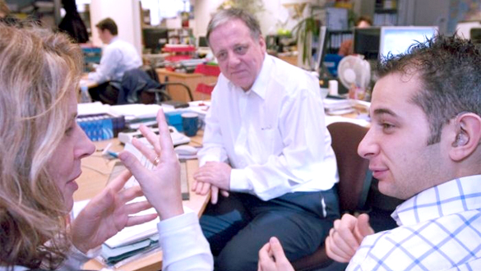

Does your hearing affect you at work? If your answer is ‘yes’, Access to Work (NI) could help pay for communication and equipment support.

Communication support – it’s your right
It’s vital that you are able to access communication support if you are deaf or have a hearing loss. Don’t be shy – it’s your right to have equal access.
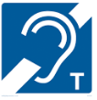
Access to Work (NI) can help people with disabilities who wish to take up employment, or who are in work and experience difficulties related to their disability. Support is available from Disability Employment Service if you have acquired a disability or if you need support due to a disability. Access to Work (NI) also helps employers who wish to recruit or retain people with disabilities in employment.

How it Works

Access to Work (NI) is designed to overcome the practical problems caused by disability. It offers advice and help in a flexible way that can be tailored to suit the needs of an individual in a particular job, or getting to and from work.

Access to Work (NI) can contribute towards the additional approved costs that arise, for example, towards the cost of communication support at interview, the provision of a support worker, provision of equipment, etc.

Who can apply?

Access to Work (NI) is open to people with disabilities wishing to take up work or people who are in work and are experiencing disability related employment barriers. Additional information on the Access to Work (NI) programme is available through Employment Service Advisers based in local Jobs & Benefits offices/Job Centres. Please click here to obtain the contact details of offices in Northern Ireland.

How do I apply?

In the first instance it will be necessary to inform your line manager / HR Services of your intention to apply to Access to Work (NI) who will support you in every way possible.

To apply for assistance through Access to Work (NI) you should contact an Employment Service Adviser in your local Jobs & Benefits office or Job Centre. The Access to Work (NI) application must be made by the disabled person. The Employment Service Adviser will refer the application to an Access to Work (NI) Adviser who will normally visit the disabled person’s place of work and advise on the most cost effective solution.

What funding is available?

Funding varies depending on individual needs but is available for as long as it is required up to a maximum of three years. After that, if support is required to continue, it will be considered under the rules of the programme in operation at that time.

Adapted from NI Direct website September 2020

13 College Accessible Information Policy

Introduction

Accessible information is information presented in a format that can be easily used and understood by its intended audience. The provision of good quality information is central to the delivery of effective and efficient public services. Everyone should have access to appropriate information so that they can access services and exercise their rights.

Aim

The North West Regional College is committed to Equality of Opportunity and to the principle of making oral and written information as accessible as possible. We aim to ensure that thought is given to providing information in a format appropriate to meeting a range of information needs, including: people with hearing impairments, sight impairments, learning difficulties, literacy difficulties, physical disabilities and people whose first language is not English.

The full policy is available at the following link
http://nwrc-vweb2/Documents/Staff/Policies/Accessible%20Documents%20Policy%20-%20New%20-%20November%202022%20(Version%202).pdf

14 Additional Support Organisations for Deaf and Hard of Hearing People

All of the below organisations have a contact in Northern Ireland

Association of Lipspeakers
Professional body representing lipspeakers
alsinfo@lipspeaking.co.uk www.lipspeaking.co.uk

British Association of Teachers of the Deaf (BATOD)
Represents the interests of teachers of deaf children and young people in the UK
exec@batod.org.uk for general queries and advice
www.batod.org.uk

British Deaf Association (BDA)
Campaigns for the rights of sign language users and works with communities across the UK
The NICVA Building, 61 Duncairn Gardens, Belfast
BT15 2GB

bda@bda.org.uk www.bda.org.uk

British Society for Mental Health and Deafness
Promotes the development of accessible mental health services for people who are deaf
c/o Self Help UK, 21-23 Pelham Road, Nottingham NG5 1AP
info@bsmhd.org.uk www.bsmhd.org.uk

Deafblind UK
Champions the rights of all people who are deafblind and provides a variety of services.
167-169 Great Portland Street, 5th Floor, London
W1W 5PF
Telephone 0800 132320
Text 07903572885
info@deafblind.org.uk www.deafblind.org.uk

The National Deaf Children’s Society (NDCS)
Supports deaf children, young people and their families to overcome the challenges of childhood deafness
The NICVA Building, 61 Duncairn Gardens, Belfast BT15 2GB
Telephone 028 9035 2011 (v)
nioffice@ndcs.org.uk www.ndcs.org.uk

The National Registers for Communication Professionals working with Deaf and Deafblind people (NRCPD)
Holds the national registers of qualified sign language interpreters and other communication professionals in the UK
Portland House, Belmont Business Park, Durham, DH1 1TW
Telephone 0191 323 3376 Text 07526 173329

enquiries@nrcpd.org.uk www.nrcpd.org.uk

RNID
Brightfield Business Hub, Bakewell Road, Orton Southgate
Peterborough PE2 6XU
Telephone 0808 808 0123
Text 07360 268 988
contact@rnid.org.uk https://rnid.org.uk/

Royal College of Speech and Language Therapists
The professional body for speech and language therapists in the UK
Suite 506, Scottish Provident Building, 7 Donegall Square West
Belfast BT1 6JH
Main switchboard
Telephone 028 9044 6385
info@rcslt.org www.rcslt.org/

Sense
Supports and campaigns for children and adults who are deafblind or have sensory impairments.
Sense NI, The Manor House, 51 Mallusk Road, Newtownabbey
BT36 4RU

Telephone 028 9083 3430
nienquiries@sense.org.uk www.sense.org.uk

Signature
The awarding body for British and Irish Sign Language courses around the UK and publisher of information about interpreter training programmes and exams
Shannon House, Mandale Business Park, Belmont, Durham DH1 1TH
Telephone 0191 383 1155
Text 07974 121594

enquiries@signature.org.uk www.signature.org.uk

NI contact
Lynn.vest@signature.org.uk
Telephone 0191 383 7901

Further information from RNID
The helpline offers a wide range of information on many aspects of hearing loss, including communication training and services. Please contact them to find out more about their free leaflets and factsheets. Alternatively, you can download them for free at
Information leaflets - RNID
