Derry~Londonderry
Strand Road, Londonderry, BT48 7AL
Tel. 028 7127 6000
Fax. 028 7126 0520
Textphone 028 7127 6167

The College welcomes calls via Relay

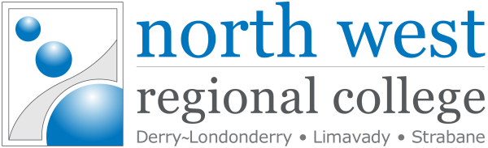
Principal & Chief Executive:
Mr Leo Murphy BSc (Hons), DipAcc, DipEd, MBA, MCIM
www.nwrc.ac.uk info@nwrc.ac.uk

December 2023
Statement of Compliance
UK Modern Slavery Act 2015
This is to confirm that North West Regional College and its subsidiaries have read and understood the UK Modern Slavery Act and will meet its requirements where possible.

As an organisation we are committed to safeguarding and promoting the welfare of learners, employees and volunteers, with a safeguarding policy and procedure in place covering all forms of exploitation, including slavery or practices similar to slavery.
Leo Murphy
Principal & Chief Executive

